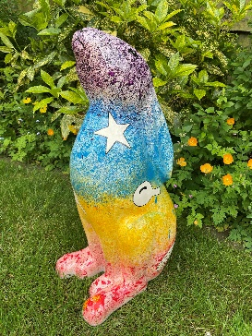
Artemis On Tour
Booking Form
Unit Details
Division
District
Unit

Contact Details
Name
Email Address
Telephone Number
Address

Preferred Dates for Visit
1st Choice
2nd Choice
3rd Choice

Please note leaders will be required to collect/drop off Artemis before and after your event.

Please send completed form to admin@bedsguiding.org.uk

