Get on the water

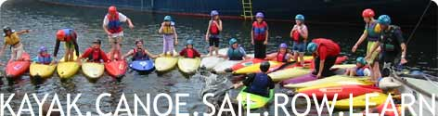
Watersports taster weekend at London Docklands Scout Project
What? Fun-filled weekend of water-based sports and activities
When and where? 17-19 May 2024
Dockland Scout Project Headquarters Training Ship
“Lord Amory”
Who is it for? Groups of up to 4-8 Guides/Rangers with accompanying Leader who will be expected to share in the organization and running of the weekend
Proposed Activities Range of water-based activities which may include kayaking, canoeing, rowing, sailing, bellboats, keelboats
Cost £135 per Young Member
£60 per Leader
£40 non-refundable deposit required with booking
What’s included? Coach Transport, accommodation, all activities
Meals from Friday evening to Sunday lunchtime.
Other information
Places are strictly limited. Bookings accepted up to Friday 17 February 2024 or until full. Should the minimum numbers not be achieved, we reserve the right to cancel this event in which case all monies paid will be refunded. Otherwise, monies paid are not refundable. Bookings will be acknowledged by email within 7 days of receipt.
Girls will need to bring with them appropriate kit – further information will be supplied.
It is anticipated that the event costs will be fully met by the participant fees and should there be any financial surplus, this will be small in relation to the number of participants and will therefore be used to further guiding within Girlguiding Bedfordshire.
If you have any questions or require further information about this event, please contact Ann Crome on volunteer@bedsguiding.org.uk

