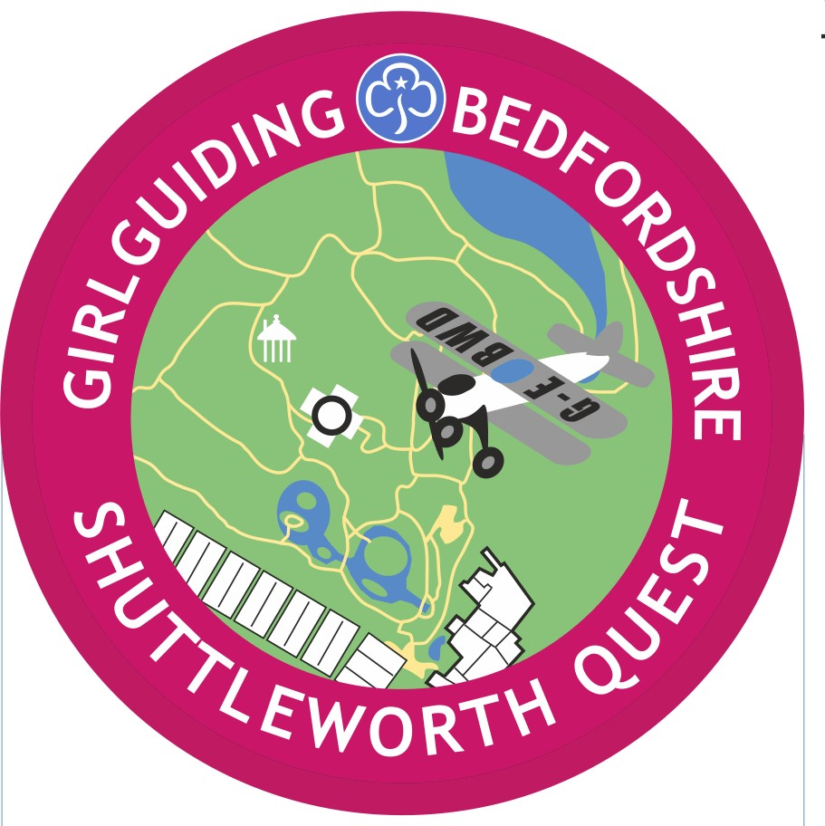


SHUTTLEWORTH CHALLENGE

BADGES
The Badges should be ordered from events@bedsguiding.org.uk

The badges cost £1.00 each.
…………………………………………………………………………………………………………………………….

SHUTTLEWORTH CHALLENGE – BADGE ORDER FORM

Date of visit ………………………….. Unit ……………………………………………………
BADGE | NO | PRICE PER BADGE | COST
Challenge Badge |  | 1.00
Free to collect or
Up to 10 badges |  | Add £1.50 p&p
10 or more |  | Add £2.50 p&p
 |  | Total

I enclose a cheque payable to Bedfordshire Guide Association for £………………
please send to - 145 Holme Court Avenue, Biggleswade, SG18 8PB
or by bank transfer to:- Bedfordshire Guide Association sort code 30-14-71 account 00929293 . Whichever way the money is sent, please add the reference, 23-016

Please send the badges to
………………………………………………………………………………..
………………………………………………………………………………………………………………………….
…………………………………………………………………………………………………………………….
…………………………………………………………………………………………………………………………….

