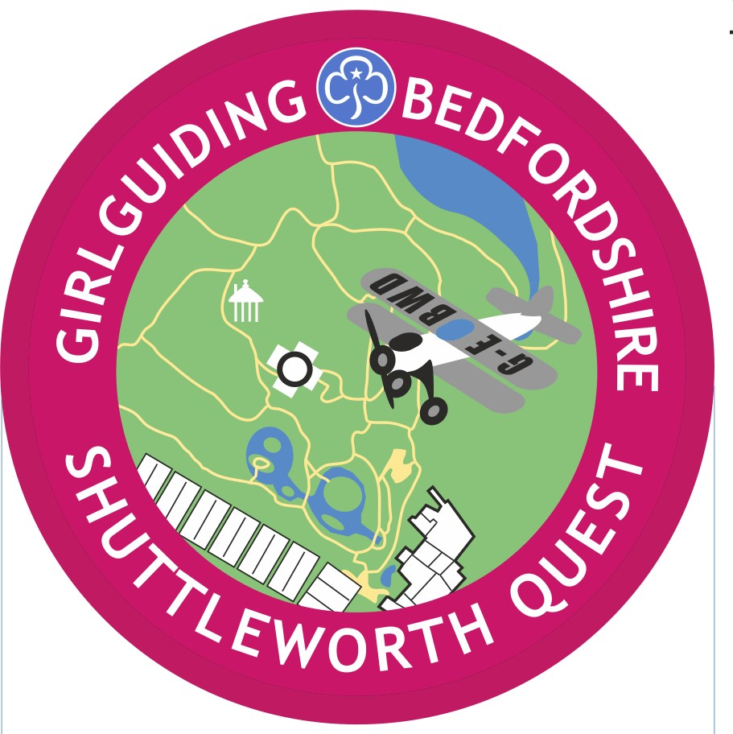


SHUTTLEWORTH QUEST – FAQs

What is the Shuttleworth Quest? An opportunity for members of Girlguiding Bedfordshire to visit a local historic landmark and to complete a STEM Quest on the Shuttleworth Collection and go on a Map Quest through the Swiss Garden.
Where is Shuttleworth? Shuttleworth is in Old Warden, just off the A1 near Biggleswade.
Who is the Quest for? There are separate quests for Rainbows, Brownies and Guides/Rangers/Adults. The Rainbow version needs adult input, the Brownie version can be done with adult supervision, the Guide+ version can be done in small groups.
What are the recommended group sizes? They will book a minimum group of 10 and Maximum of 30 girls.
When can the Quest be done? When Shuttleworth is open, unless there is a major event on, visit https://www.shuttleworth.org/events/
How long does the Quest take? The STEM Quest takes about 2 hours and all Sections and units should allow about the same time for the Map Quest. If you are intending to have lunch or a picnic or use the playground, you will need a minimum of 5 hours so this would be a full-day event. We would also recommend you take a 30 min break at lunch time in the Garden room to complete the sheets in addition to the lunch break as the day involves a lot of walking and this was found to work well to keep energy levels high.
What does it cost? The charge is £ 8.50 per young participant. Shuttleworth then offer 1 free adult place per 5 girls. Extra adults or Adult only groups is £15 a head. This covers entrance to the Shuttleworth Collection and the Swiss Garden, all materials. This is paid to Shuttleworth by invoice. Once you have booked don’t forget to order your badge. This is available at a cost of £1 each from events@bedsguiding.org.uk See Order form.
How do we pay? After you have made a booking you will be sent an invoice. This can be paid by bank transfer or unit cheque but must be paid and time left for a cheque to clear before the visit.
What else do we need to know? There are ample toilet facilities on the site, a gift shop and an adventure playground (suitable for children up to 12 years old). Your group will have access to a dedicated room for the time of your visit, which can be used for lunch and to leave bags etc. The site is level access.

Where can I find out more? By contacting the Learning Co-coordinator, Matthew Studdert-Kennedy at learning@shuttleworth.org
Or by contacting Girlguiding Bedfordshire events@bedsguiding.org.uk
How to book:- Email Matthew, as above, for availability. Once a date is confirmed you will need to send a booking form to him. All paperwork for the visit is then available on www.bedsguiding.org.uk

