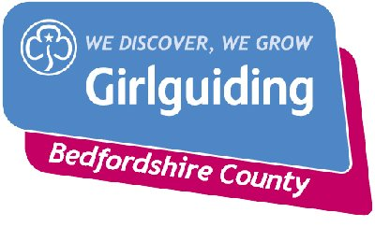
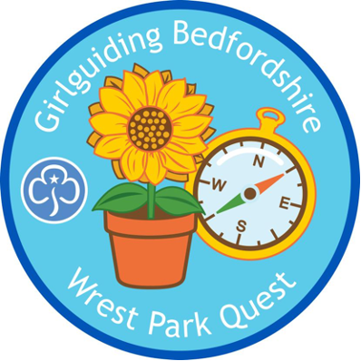

WREST PARK QUEST

HOW TO BOOK VISIT
To check availability and book your visit, you need to visit the Wrest Park Webb Page, School visits, enquire now, start a new booking enquiry. Send this form off and they will come back to confirm booking. Please note the Education room is not available on the 2nd Saturday in the Month.
Please mention that you are part of Girlguiding Bedfordshire and wish to complete the Wrest Park Quest on your booking form.
BADGES
The Badges should be ordered from events@bedsguiding.org.uk

The badges cost £2.00 each, which includes a contribution to the Environmental Quest.
…………………………………………………………………………………………………………………………….

WREST PARK QUEST – BADGE ORDER FORM

Date of visit ………………………….. Unit ……………………………………………………
BADGE | NO | PRICE PER BADGE | COST
Rainbow (red edge) |  | 2.00
Brownie (brown edge) |  | 2.00
Guide (blue edge) |  | 2.00
Free to collect or up to10 |  | Add £1.50 p&p
Over 10 |  | Add £2.50 p&p

I enclose a cheque payable to Bedfordshire Guide Association for £………………
please send to -145 Holme Court Avenue, Biggleswade, SG18 8PB
or by bank transfer to :- Bedfordshire Guide Association sort code 30-14-71 account 00929293. All payments, whichever way sent, need the reference, 23-015 please.
Please send the badges to
………………………………………………………………………………..
………………………………………………………………………………………………………………………….
…………………………………………………………………………………………………………………….

