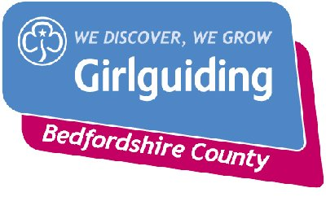
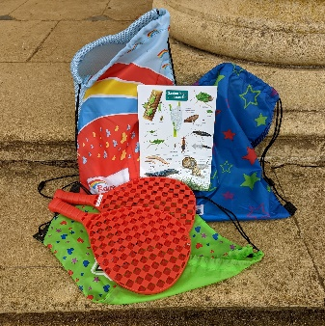

WREST PARK QUEST – FAQs

What is the Wrest Park Quest? An opportunity for members of Girlguiding Bedfordshire to visit a local historic landmark and to complete an Environmental Quest in the Education Centre and go on a Treasure Quest through the grounds which can also be linked to the skill builders.
Where is Wrest Park? Wrest Park is in Silsoe, just off the A6 near Clophill.
Who is the Quest for? There are separate quests for Rainbows, Brownies and Guides age upwards. The Rainbow version needs adult input, the Brownie version can be done with adult supervision, the Guide + version can be done in small groups. The quest is made to be flexible , so your unit can complete as much or as little of the quest that works for you.
What are the recommended group sizes? Group sizes are limited by the number that can be accommodated in the Education Centre at any time (about 30) so this is more suitable for units. Suggested minimum is 10 and maximum would be 2 groups of 30.
When can the Quest be done? As there is no longer dedicated Education Support at Wrest Park, it can be done on any date that there is a free slot other than the 2nd Saturday each month, which is not available.
How do I book? To check availability and book your visit, you need to visit the Wrest Park Webb Page, School visits, enquire now, start a new booking enquiry. Send this form off and they will come back to confirm booking. Please mention that you are part of Girlguiding Bedfordshire and wish to complete the Wrest Park Quest on your booking form.
How long does the Quest take? The Quest can be adjusted to take as little or long as you want. The environmental activity needs about half an hour in the education room. The Treasure Quest has lots of options and a sheet linking it to the skills builders which you can add in as you want. If you are intending to have lunch or a picnic you will need a minimum of 4 hours but this can easily fill a whole day.
What does it cost? For pre booked education groups there is no charge for entering the park or doing the Quest. On booking you will receive an Education permit which you will need to bring with you and hand in at the Visitor Centre on arrival. Badges, which need to be ordered separately, cost £2.00 and include a contribution towards the cost of the Environmental Quest which is funded by Girlguiding Bedfordshire.

What else do we need to know? Toilets are available at the Visitor Centre on entry and you have toilets just for your group in the Education Room. Participants will need a drinks bottle and there is a kitchen sink in the education room if these need to be refilled.
There is a nice gift shop so don’t let them forget their pocket money to spend.
Before you go You will find several guiding bags at Wrest Park for you to use during your visit.( please leave these in good order for the next group) There will be a copy of the trail in here for you to use. You will only need to print off a copy of the indoor activity for your information. All the trails are on the County Webb site if you want to take extra copies. Paper and pens will be useful for the girls to use.
You can get a copy of the County Risk assessment from events@bedsguiding.org.uk to assist with your own Risk Assessment for the day if this helps.
And don’t forget to order your badges from the events email.
What will happen on the day? You will need to go to the Visitor Centre where you will meet an English Heritage volunteer or member of staff who will take you to the Learning Centre which is where you will do the Environmental Quest and have lunch if you wish. You will be given a set of keys to the Learning Centre and these must be returned to the Visitor Centre when you leave.
You will find all the equipment to help you run the activities in the Education room in two green boxes marked Wrest Park Challenge. Please remember your group is responsible for leaving the Learning Centre in a tidy state. There are clipboards for use with the Treasure Quests and these must be returned to the appropriate crates in the Learning Centre. Please also ensure the activity bags are returned to the Learning Centre for the next group to use.

After your visit
Order your badges if you haven’t already done so at events@bedsguiding.org.uk
Wrest Park welcome your feedback so they can ensure the Quest works ongoing for the units. Please complete the fed back form they will give you and leave it with the staff when you return the key. Girlguiding Bedfordshire also welcome any feedback or suggestions . Please email these to events@bedsguiding.org.uk

We hope you have a great day out!

