
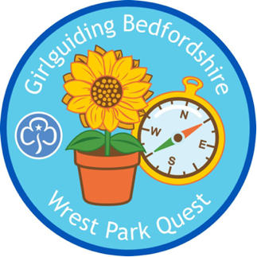


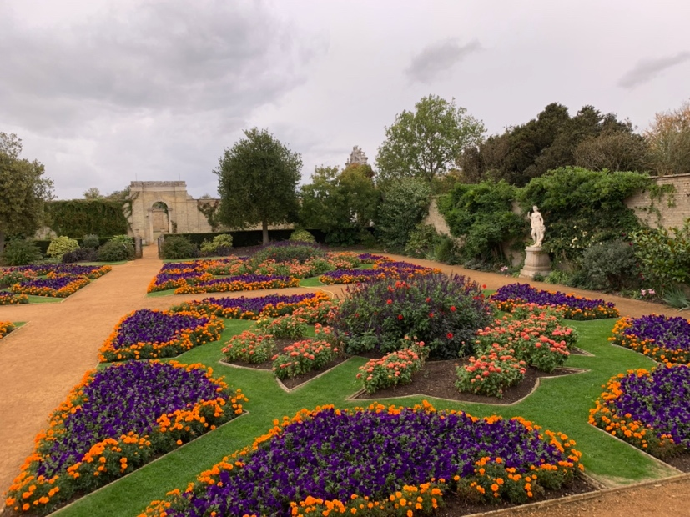

The Flower Gardens

The quest starts in the Italian Garden.

Explore the Italian Garden and then follow the pathway to the terrace.

Stand on the terrace and look down towards Archer’s Pavilion.
Take a deep breath and slowly breathe out. How does it feel to be outside in this open space? Tell a person near you how you feel.

Walk down the steps from the terrace. You are now in the Parterre. Have a look at the flowers and plants growing in this area. Can you see any patterns?

From the French word meaning ‘on the ground’, a parterre is a formal garden laid out on a level area and made up of enclosed beds, separated by gravel. Parterres often include box hedging surrounding colourful flower beds.
Parterres are designed to be seen from above, usually from the windows of the upper floors of the house. The overall pattern of a parterre is its most striking feature. What patterns can you see?

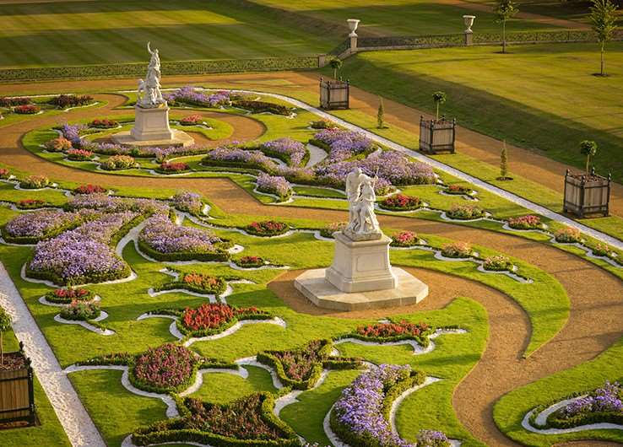

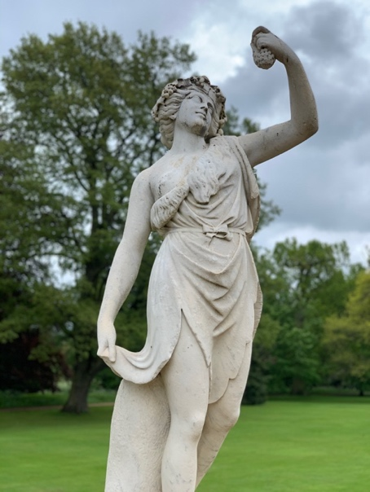
Super Statues

With the mansion behind you walk down the avenue of trees towards the first circle of statues. This is called the Round Pond and this is where the original mansion house was situated.

There are lots of statues in the garden. It was very fashionable to have statues and ornaments in grand houses and gardens. What statues or ornaments do you have in your garden?

Find a statue and strike a matching pose next to it. Take a photo.

Find a space. Run around and when your leader claps, stand still like a statue.

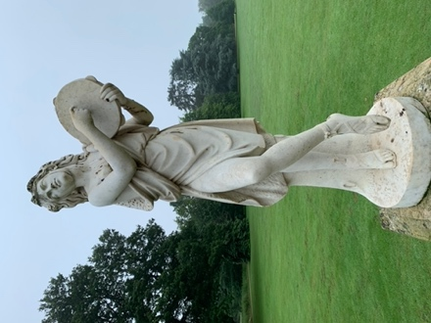
Can you find the bird girl?
Can you find the musician?

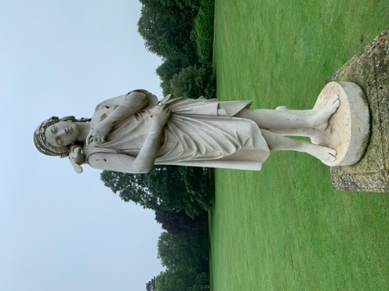

Continue your walk down the avenue towards the sundial.

What is a sundial?

Now that you are at the sundial, you will see a wide, open space in front of you with trees to the left and right. You will have a better view now of Archer’s Pavilion in the distance. This is a lovely spot to admire the view.

Mindfulness
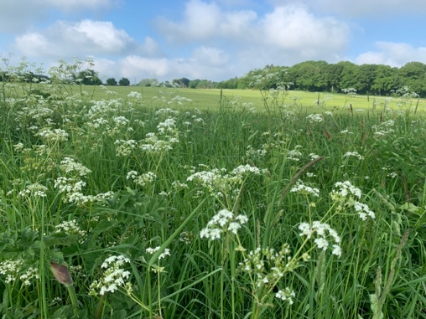
At this point, find a relaxing space and get into a comfortable position.
Take a few slow breaths and calm yourself.
While you take slow breaths think about:

5 things you can hear.
5 things you can see.
5 things you can feel.

Jemima, Marchioness Grey (1723 – 1797)

Jemima inherited Wrest Park from her grandfather Henry, Duke of Kent in 1740.

She showed a great interest in the park and gardens and loved spending time here.

Jemima was passionate about reading and the acquisition of knowledge. She loved books and nothing was more pleasurable to her then being in the gardens reading.

‘All the haymaking time I was to be found with my dog and my book among wood and purling streams’ (1744)

In our archives, we have copies of letters that Jemima wrote to her friends and family describing the beauty of Wrest Park and her love of the park and gardens.

Use your notebook to draw a picture of something you see or write a description about the landscape around you. You could even write your own letter.

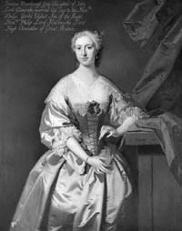

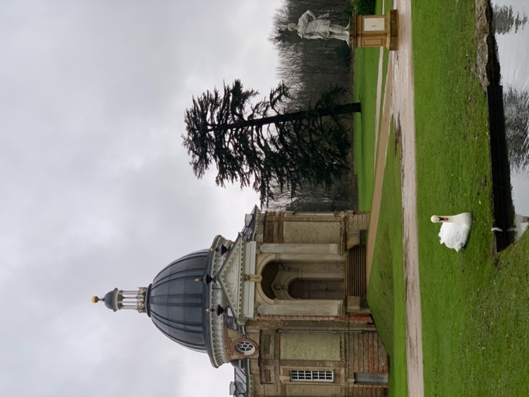
Woodland Wonders

In the distance you will see the Archer’s Pavilion.

If you look at your map, you will see that on both sides of the
park leading to the Pavilion, there is woodland.

Woodland forms a large part of the landscape here at Wrest Park.

The woodland is formed of different layers. The tall trees form a canopy which creates a shady, damp environment below. It is a perfect habitat for birds and insects. The smaller shrubs make good hiding places for hedgehogs, rabbits, squirrels and deer.

If you are very observant you might even catch a glimpse of our black squirrels.

Take a walk into any of this woodland for a nature walk.

It is time to make a nature stick to help you remember your time in the woodland.

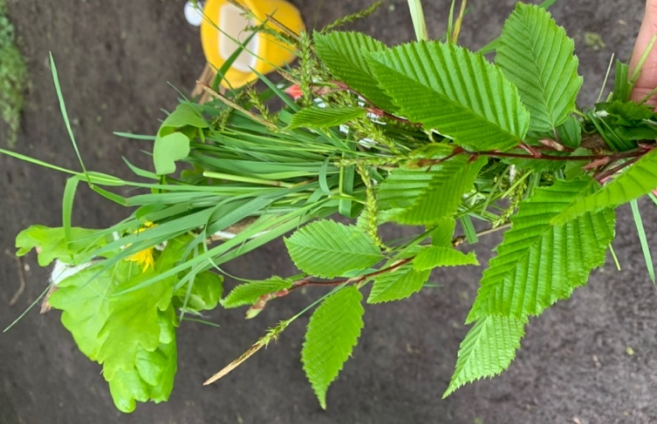
Explore and find a stick.

Get some string and tie it to one end.

Explore the woodland and collect anything that interests you.

Use the string to wrap the objects to the stick.

You can take your nature stick home with you.

Time for games

Depending upon where you are in the woods, you might need to use your map to find the Bowling Green House.

This building is over 200 years old. It is a bowling pavilion which was built around 1735 by Batty Langley for Henry de Grey, 12th Duke of Kent when he lived here.
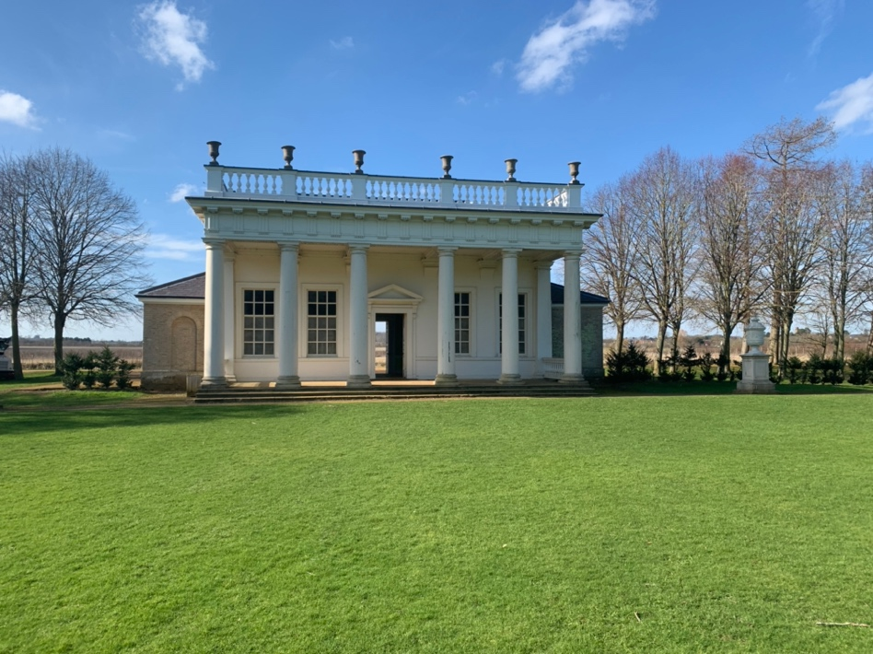
The main rooms here would have been furnished with tables and chairs. It would have been enjoyed by the family with their friends to play bowls, relax and socialise. On summer days, people would come down to the pavilion to spend the day outdoors enjoying the sunshine and playing games. Imagine people sitting on the terrace chatting and drinking tea while others competed in a game of bowls.

The green space in front of the Bowling Green House is where games
would have been played.

What games would you like to play?

Use the equipment from the English Heritage bag to make up a game
that your group can play together.



Coloured spots x3
Skipping ropes x 2
Bats x 2
Beanbags x 4



Once you have finished your game, collect up all your equipment and head
towards the orangery.

The Orangery
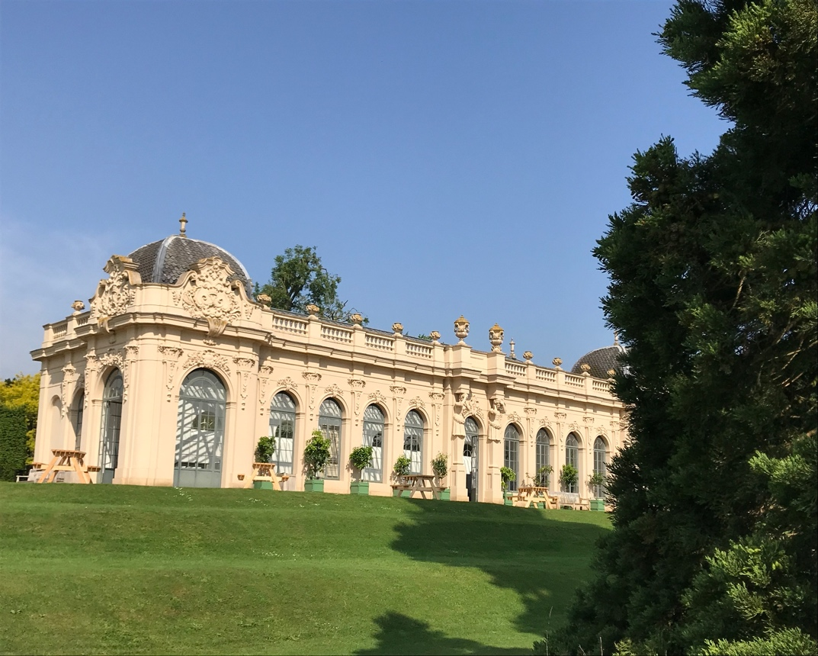
Orangeries date back to the 17th century and were built by wealthy landowners to store citrus trees in during the cold winter months.

The orangery at Wrest Park was built in the 1830s by Thomas De Grey. The orangery was filled with orange trees bought from King Louis of France which would have been quite an exceptional thing to have. Like a greenhouse, the orangery meant that fruit trees, that normally
require warmer climates, could be grown in
Statute spotter

Can you find this statue?

What do you think he is reading?

Do you think he is enjoying the book?

England where the weather is much cooler.
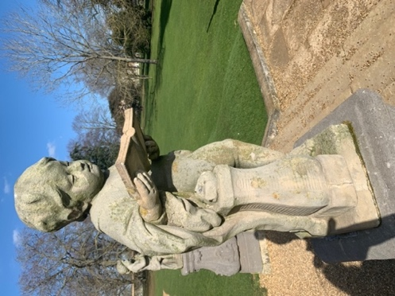

Tremendous Trees
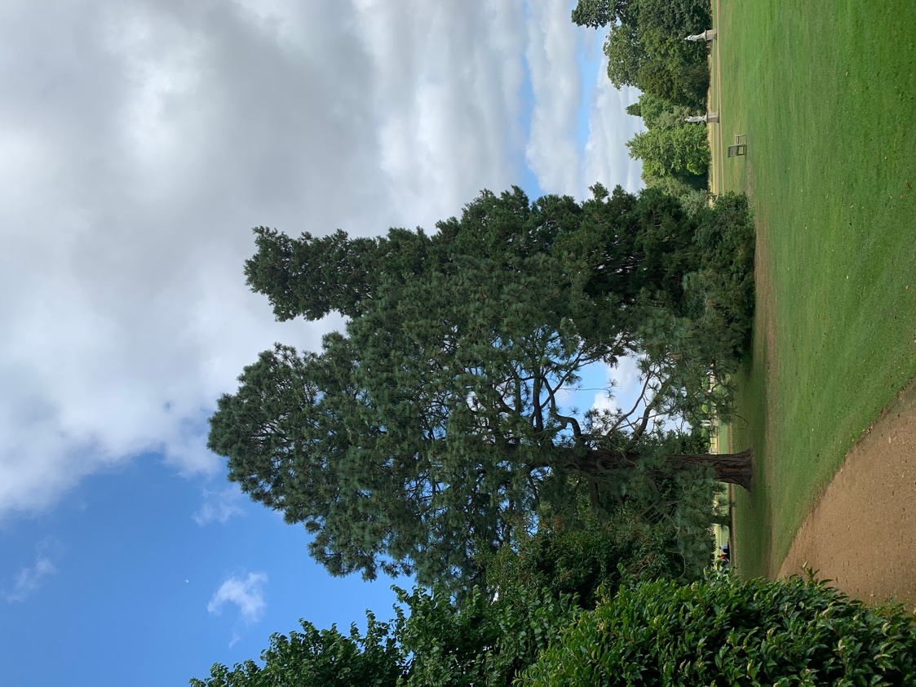
Wrest Park is bursting with trees. There are hundreds of all different shapes, sizes and species in the grounds. Trees are invaluable to us. They provide us with the oxygen we need to breathe and they also store carbon which is created by air pollution. By storing carbon inside the wood of the tree the rate of climate change can be reduced.

We can all agree that trees are tremendous.

From the orangery you will see lots of trees around you.

As you come to the end of your trail, it is time to do some tree spotting.

Have your notebooks handy so you can jot down the names of any trees you find. You can also do a sketch of a tree, a leaf or some bark.

Can you find these evergreens in the area in front of the orangery?

Evergreens are trees and plants that stay green all year round and keep their leaves during Autumn and Winter. Deciduous is a word used to describe trees and plants that lose their leaves at certain points in the year, usually Autumn.

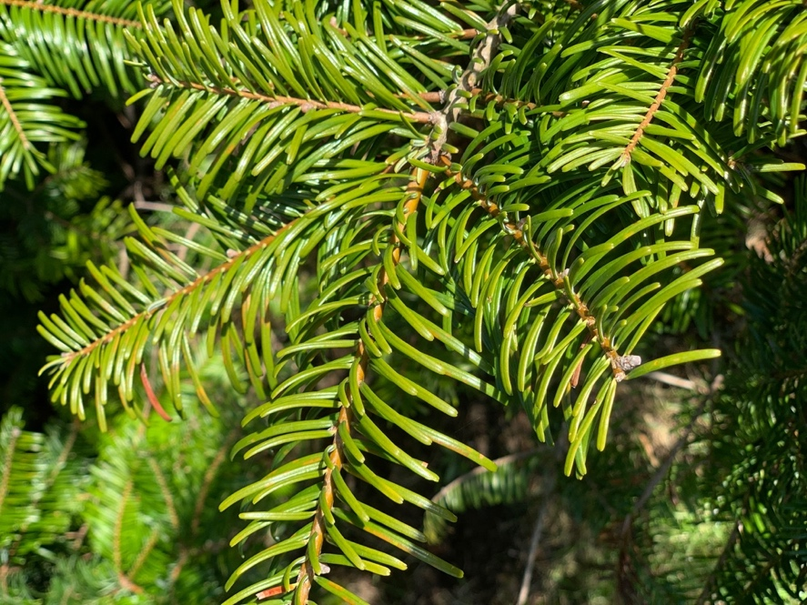
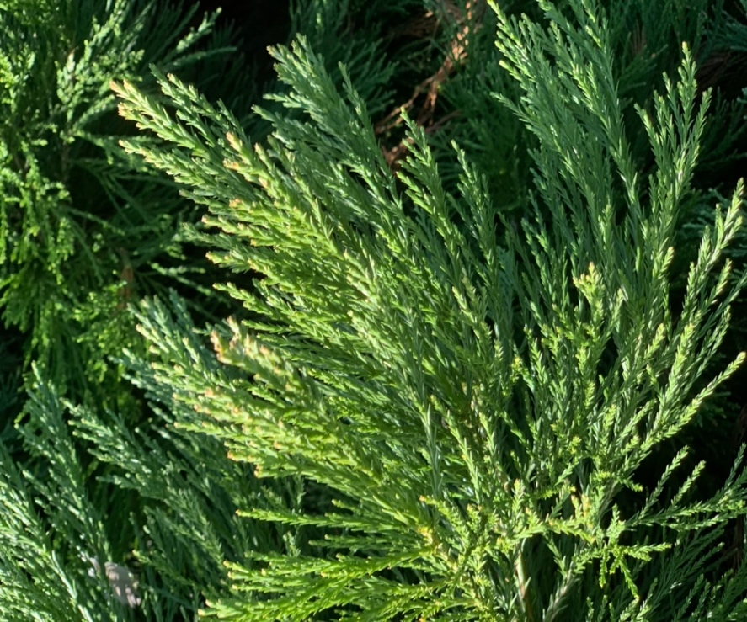

Pine trees have needles instead of leaves.

This is a conifer tree.

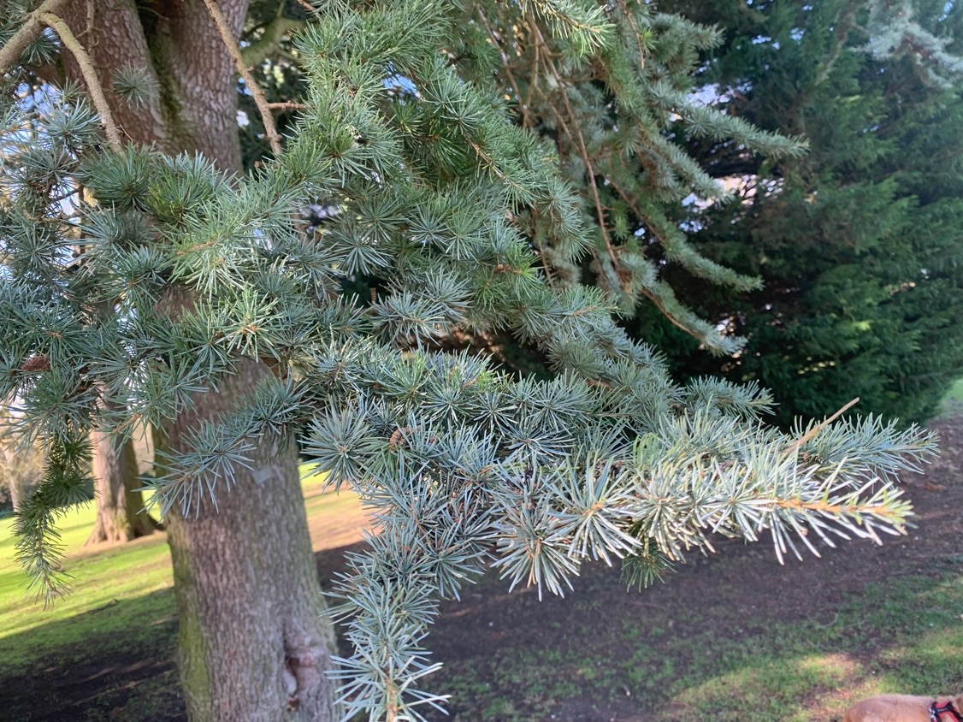

Can you find this prickly pine tree?

We can identify trees from their bark as well as their leaves.

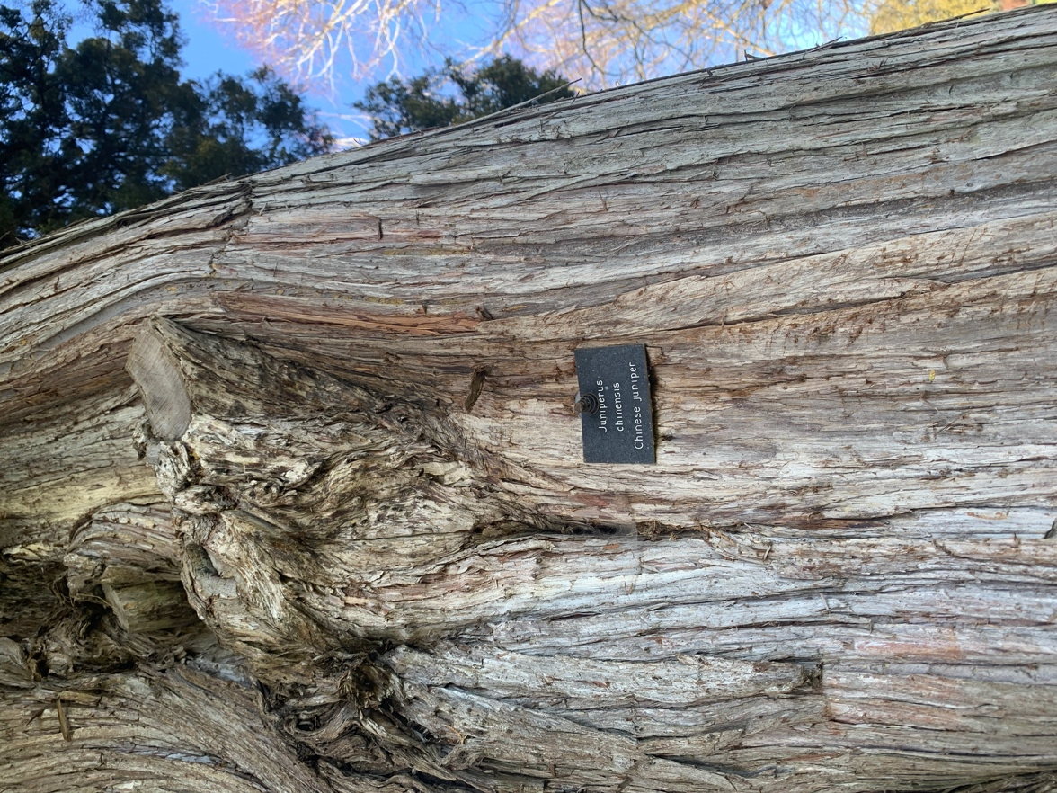
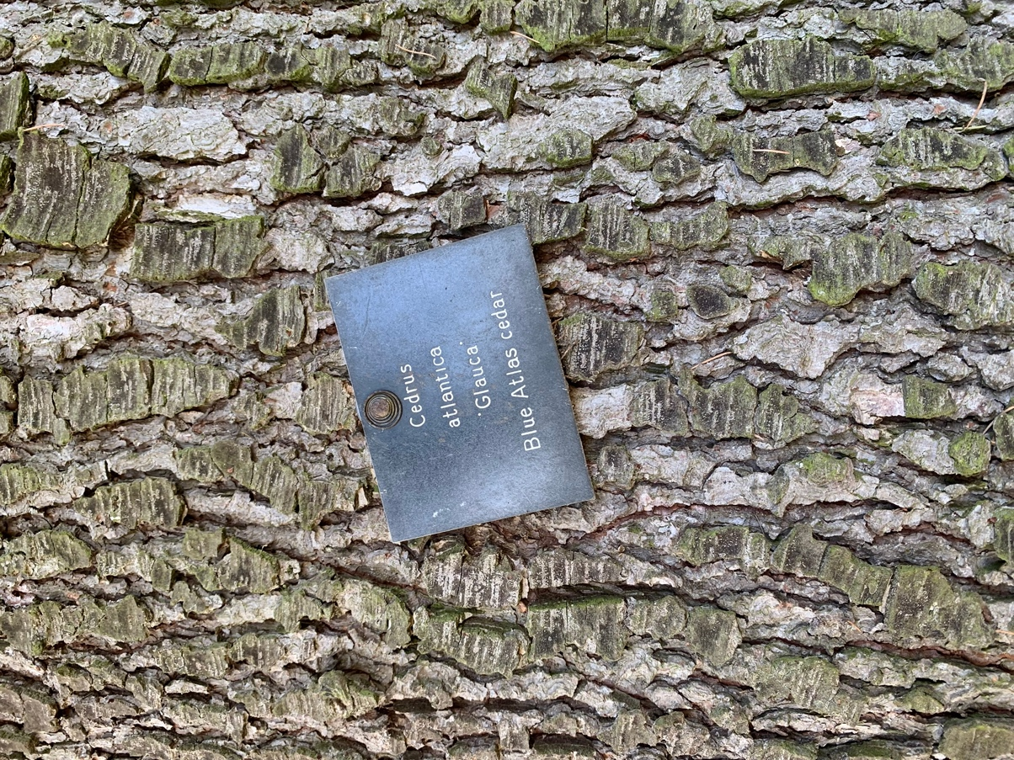

Can you find our Blue Atlas Cedar? Can you find the Chinese Juniper?

Wrest Park has a lot of Portuguese Laurel trees in the upper gardens.
Using this picture of the tree bark can you find them?

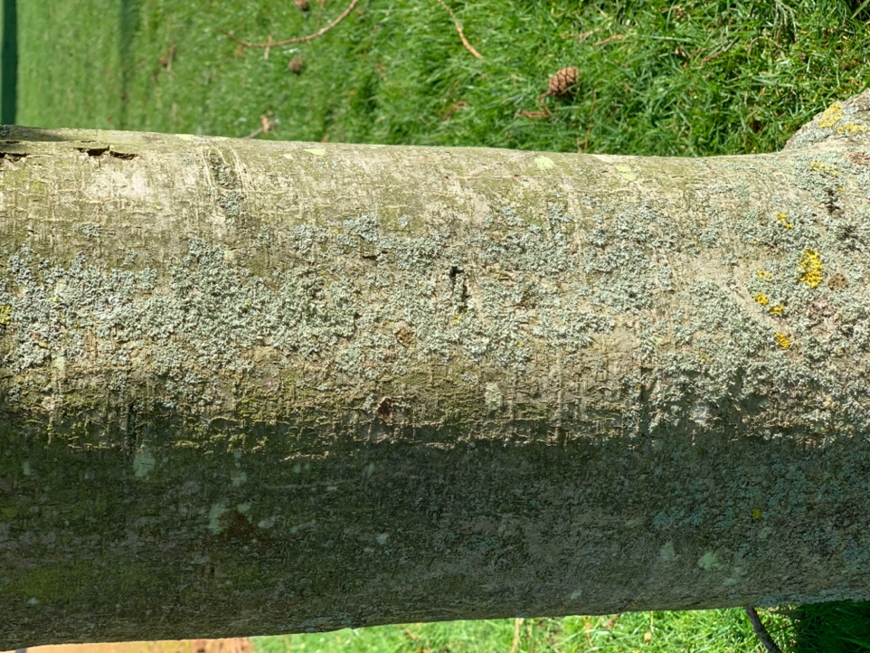

As you walk around the park and gardens, you might find the tree ID-dial in your bag useful. Or use an app on a mobile phone to identify plants and trees you find.

Now pack up your things, it is time to head back to the mansion. Follow the paths past the orangery, through the trees and back to the terrace and French Parterre where you trail is complete.

Well done!

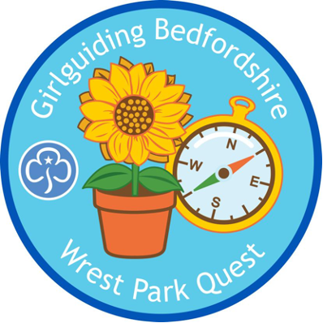

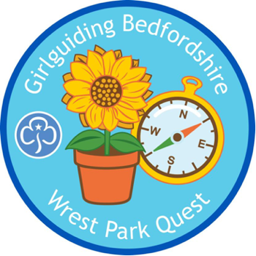

WREST PARK EXTRAS

Quiz our room guides in the mansion house.

Take a tour of the beautiful mansion and admire the state rooms. At Wrest Park we have volunteers who are room guides and they provide visitors with lots of information about the history of the house and gardens. Before you enter, think of some group questions you could ask them.
Enter the house and find a room guide to quiz with your questions.

Visit the Bath House

During the 18th century, the health craze of the day was cold baths and plunge pools as part of a healthy lifestyle. Designed as a garden feature, these plunge pools were filled with cold water where people would come for a cold swim. Bathhouses were built overlooking the landscape to enjoy the view whilst in the plunge pool. In the 18th century, taking plenty of exercise, spending lots of time outdoors and being in cold water were considered essential to living a long and healthy life.

What things do we do today to keep fit and healthy?

Nature Art

Collect natural objects around the park and gardens and then find a space to create a nature picture. Perhaps you could create a picture of Wrest Park. Take a photograph and share it with us on social media.

Make a map

Use the landmarks in the grounds to design your own map of Wrest Park.

Book lovers

Jemima, Marchioness Grey (1723 – 1797)

Jemima was passionate about reading and the acquisition of knowledge. She loved books and nothing was more pleasurable to her then being in the gardens reading.

‘All the haymaking time I was to be found with my dog and my book among wood and purling streams’ (1744)

On your trail you will have learned about Jemima, Marchioness Grey who inherited Wrest Park in 1740. Bring along to Wrest Park one of your favourite books and like Jemima find a nice place to sit and read it.

Girl Guiding Association Skills Builder Links

Wrest Park is a great place to complete some Skill Builder goal

Stage 1  Rainbows Survey  Observational skills and recording | Stage 4  Uncover and Discover  Observational skills
Explore Local  Understand what a landmark is  Explore a local area  Create a landmark map | Stage 5  Explorers Handbook  Discover how to document like an explorer  Record your travels  Be creative
Stage 2  Naughty Elephants Squirt Water  Using a compass | Stage 6  Decipher the Direction  Create a trail

Spring Spotter

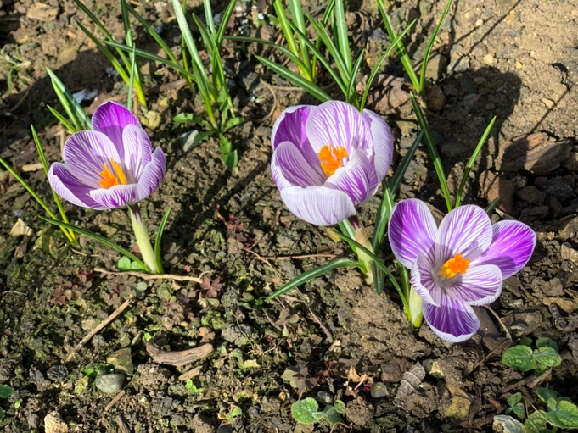

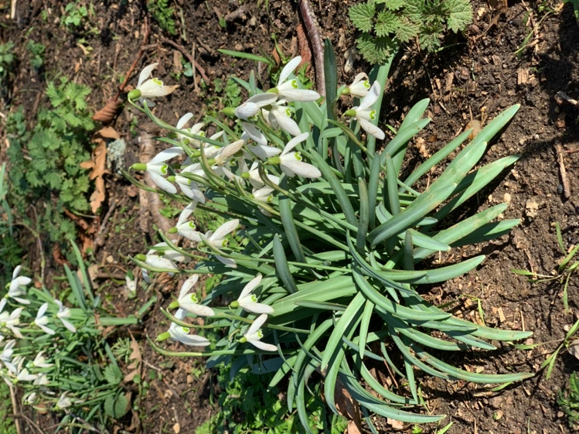
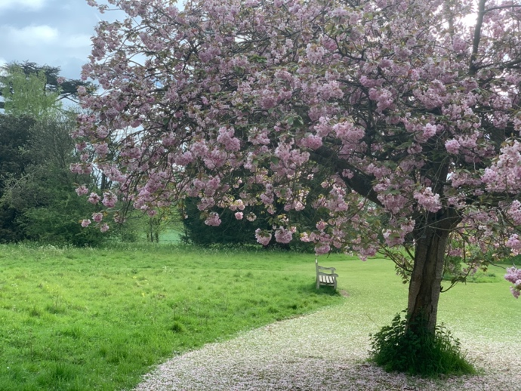
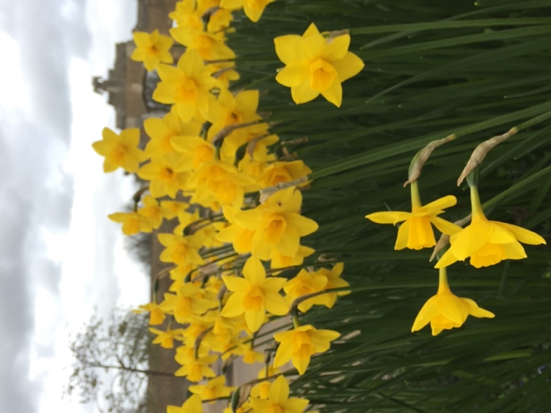
snowdrops
Blossom tree by the Chinese Bridge
crocus
daffodils

Did you know?

Bulbs live happily under the ground for most of the year, until the flowers pop up in Spring. The plant eventually dies back and it happens all over again the next year.

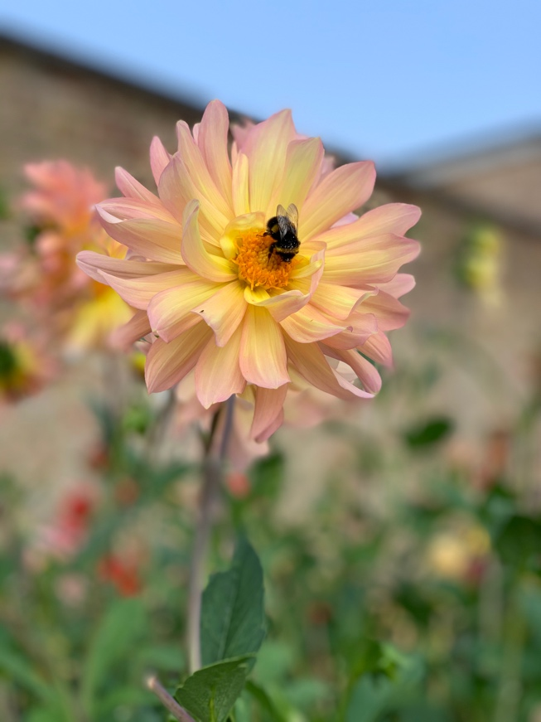
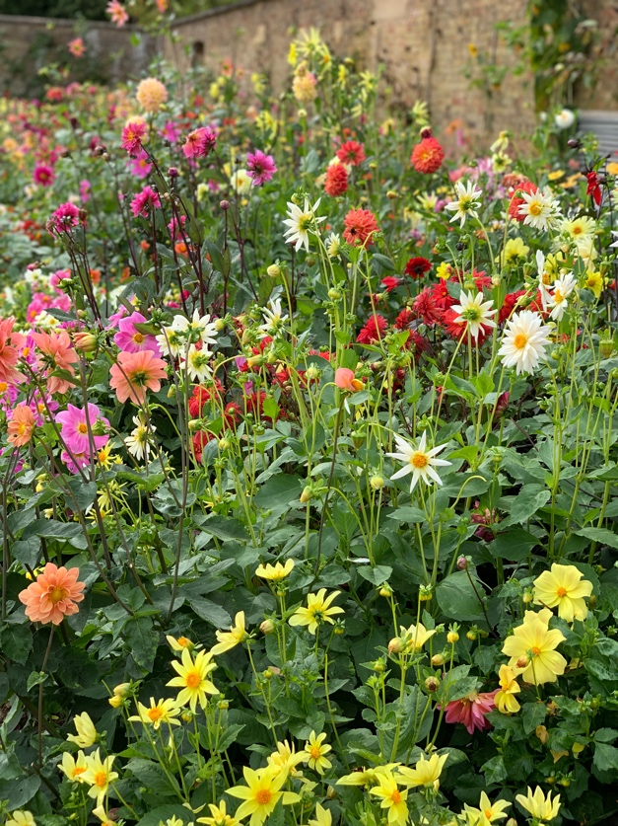
Summer Spotter

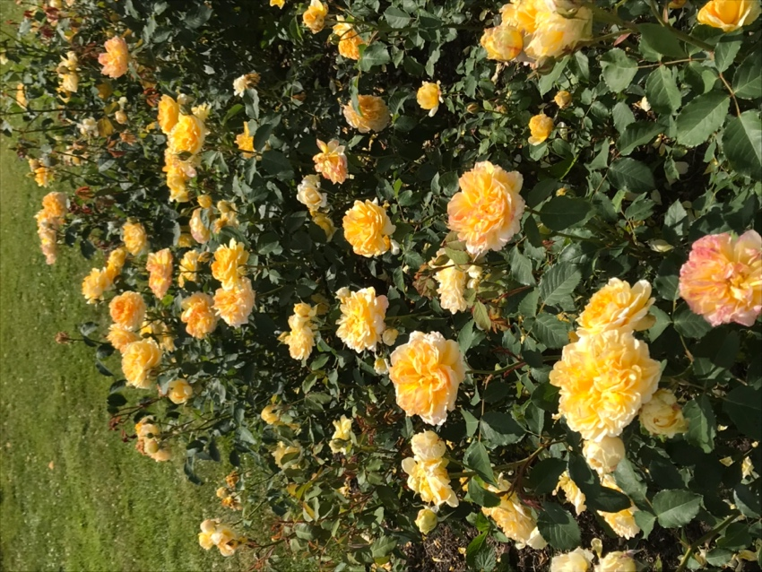
bees
Sweet smelling roses

A rainbow of flower colour appears in the walled garden
Did you know?

Wrest Park has a collection of bee hives and we make our own honey.

Autumn Spotter
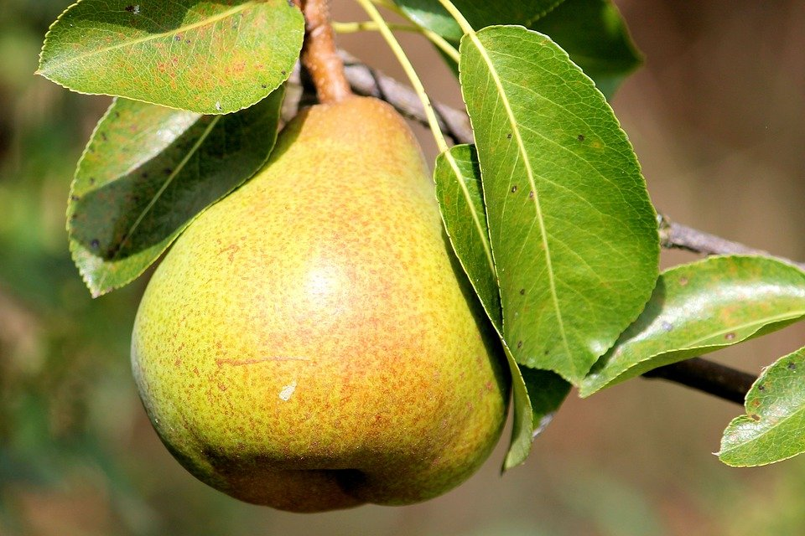


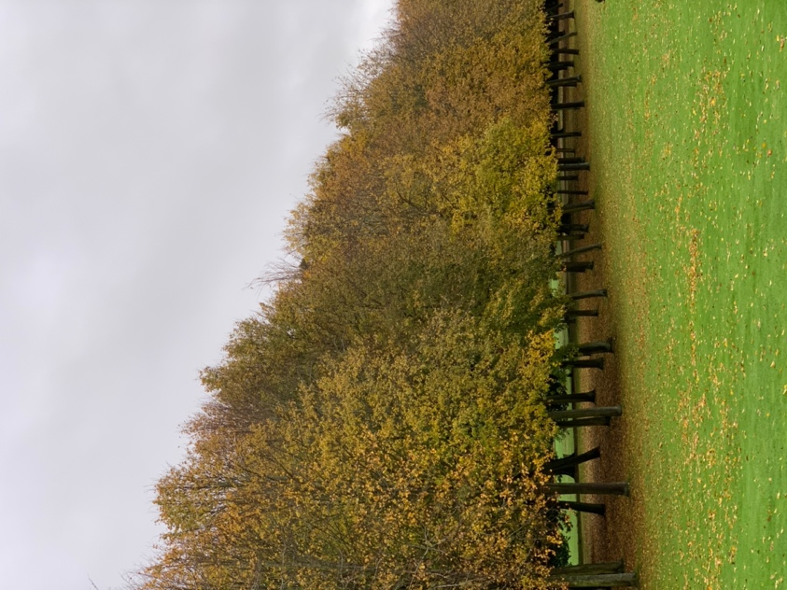

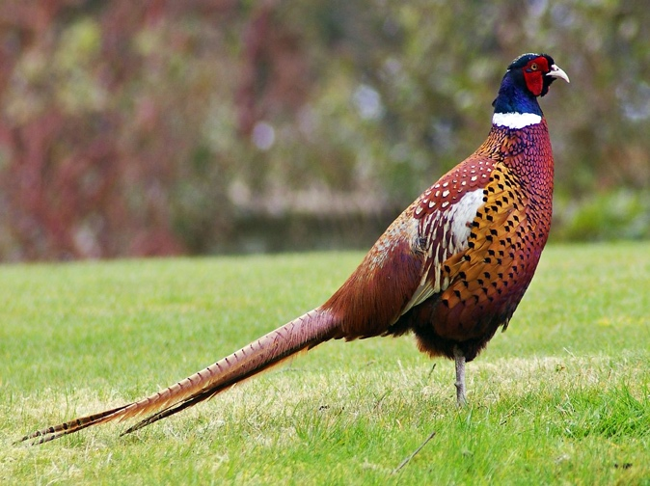
Autumn is a beautiful time of year at Wrest Park. The leaves begin to change colour.

What colours can you see?

pears
pheasant
This Photo by Unknown Author is licensed under CC BY-SA
Squirrel
Autumn colour

