Wrest Park 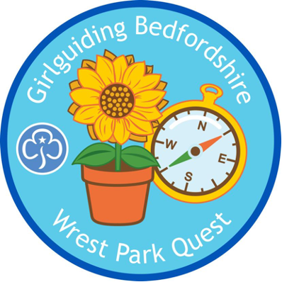

We have been asked for a list of Skills builders and badges that could be linked to the Wrest Park visit. There may be others that you also think work but here are a few ideas.

Skills Builders
Stage 6
Explore- Decipher the Direction
Explore – Tech-No-Logg
Explore – Bon Voyage

Stage 5
Explore- G.P.Yes
Explore- Explorers handbook
Explore- Root out the way
Explore- Wash it off
Explore- Explores handbook
Camp- Shelter Sleepover
Reflect- Trying out Traditions

Stage 4
Communicate- Signs of the times
Innovate- Walk of the town
Explore- Uncover and discover
Camp- Stuck in the mud
Network - Paper planner

Stage 3
Camp- Invent a gadget
Camp- Night under the stars
Explore- Navigate to treasure
Explore- Suss out the symbols

Stage 2
Make change- Environmental detectives
Live smart- Indicator navigator
Explore- Mapping it out
Explore- Naughty elephants squirt water
Explore- A country walk

Stage 1
Camp- Tent tastic
Explore- Explore local
Explore- Signs from the sun
Make change- Growing cups of kindness
Feel good- Play time
Lead- Leadersheep
Live Smart- Safety Superheroes

Unit activities
Rainbows
Survival skills- A race against time
Personal safety- Stay alert
Explore Nature- Hide and seek hunt
Explore Nature-Birdie Builders
Explore Nature - Hidden Nature
Explore Nature - Bug Hunt
Explore Nature - Tree-mendous Senses
Survival skills- Secrets of survival
Survival skills- Trails and tracks
Community Action- Rainbow survey.
Out of this world- Astronaut academy
Storytelling - Story Trail
Personal Safety – Karate Tennis

Brownies
S.T.O.P- Survival Skills
First Aid in the Field- Survival Skills
Disaster Strikes- Survival Skills
Fox, Frog, Flea – Explore Nature
Life Cycle Survival- Explore Nature
Insect Invaders- Save the Planet

Guides
Totally Ga-Ga
Plastic Planting
Biodiversity Blitz
A – Z in Nature
Wild Wax

Rangers
Tidal Tug
Destructive Discussion
Speedy Scavengers

Badges
Guides:- Aspirations, Photography, Meditation, Geocaching, Navigator, Vlogging, Upcycling.
Personal Branding, Natural Remedies
Brownies:- Grow your own, Local History, Mindfulness
Rainbows:- Healthy Mind, Nature.

